Download Git for Windows:

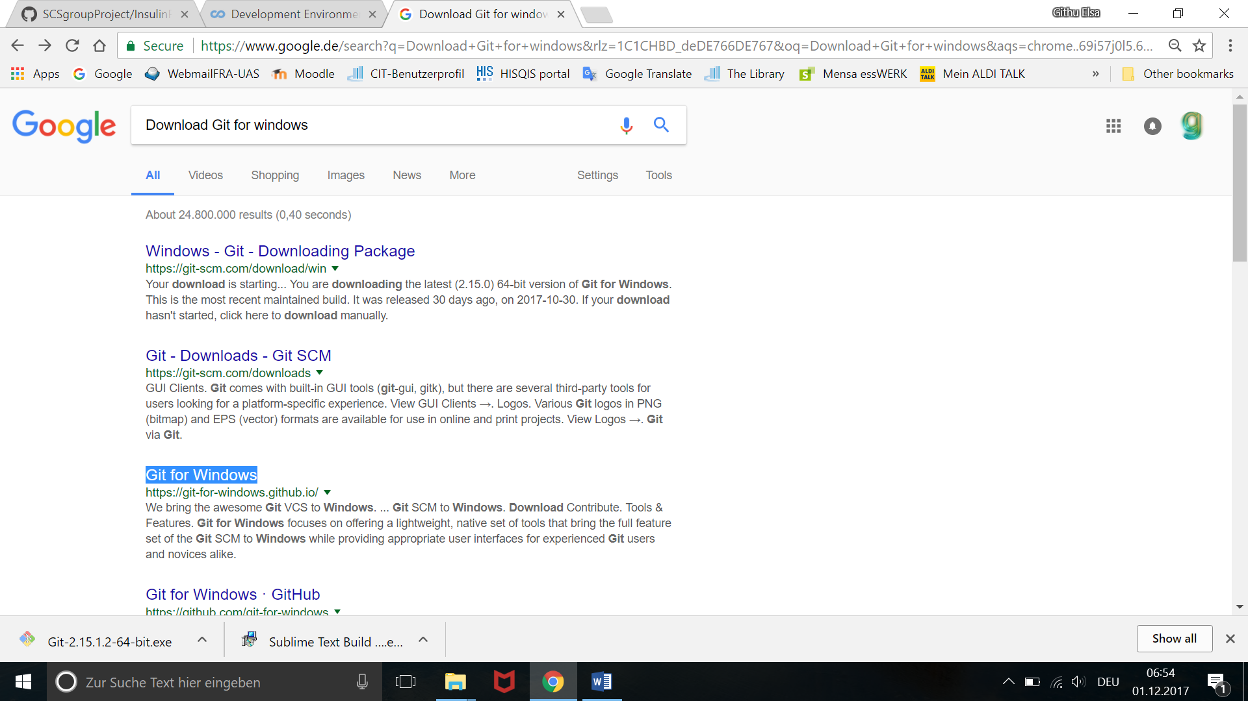

Click on download:

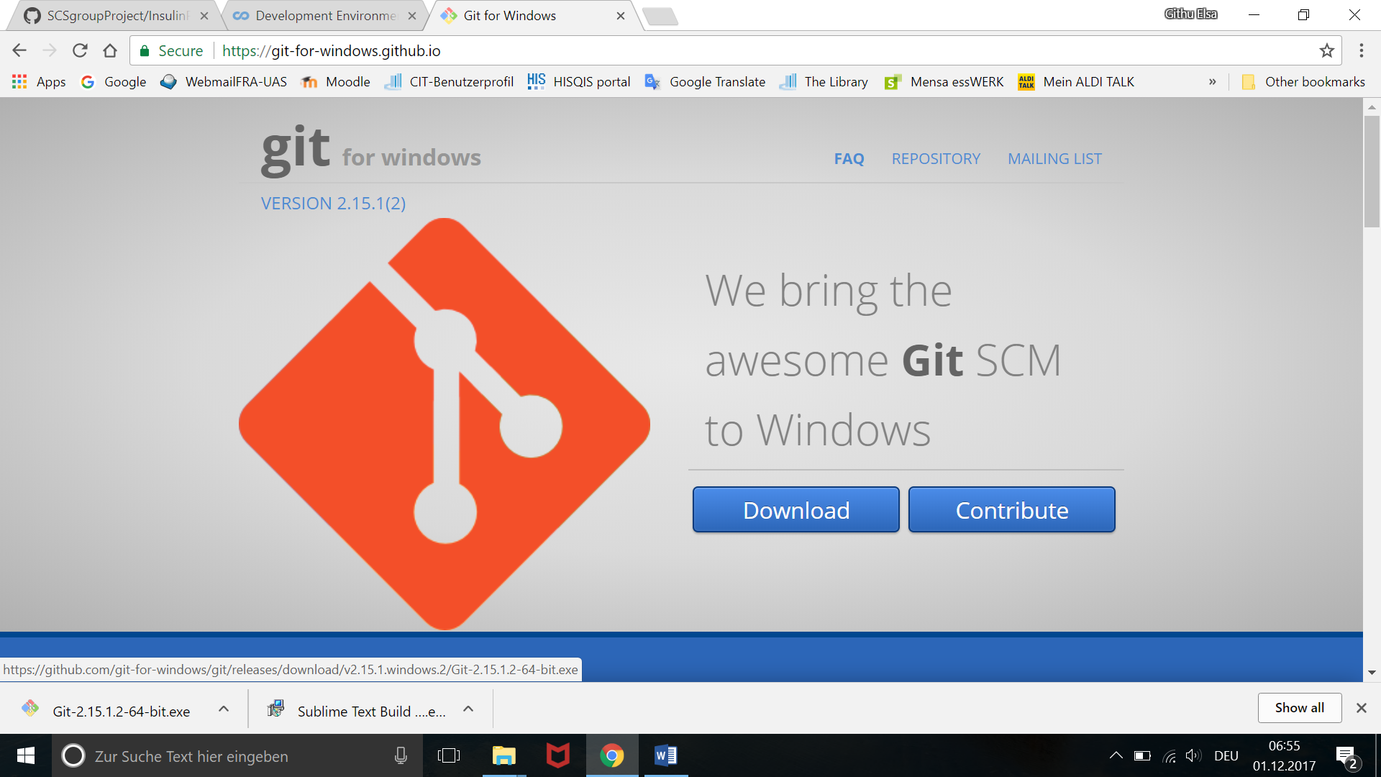

Go to the download file and execute the runnable:



Next- 4 times

Select Nano editor in the below screen:

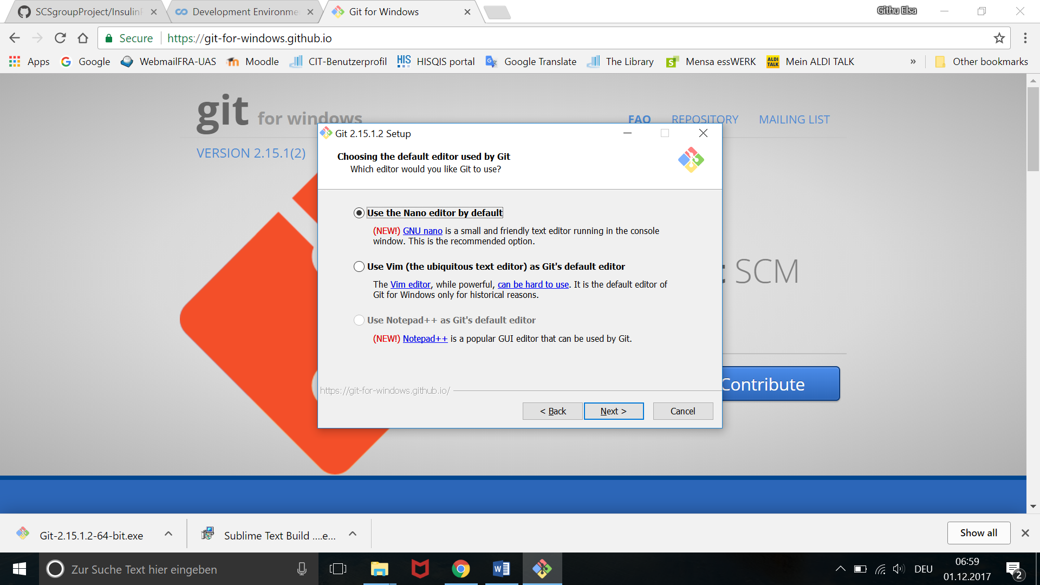

Select use Git from Windows Command prompt:

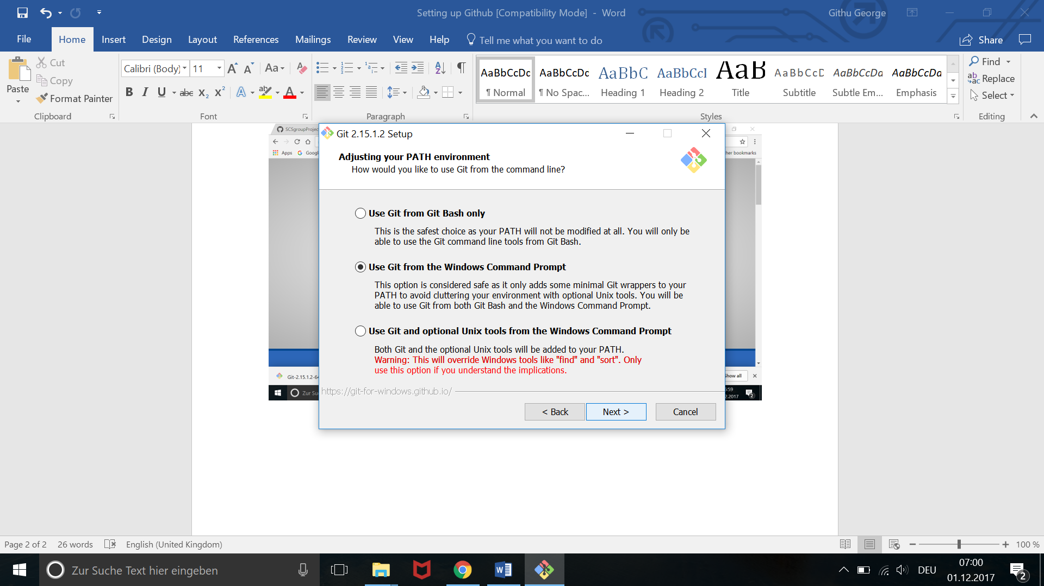

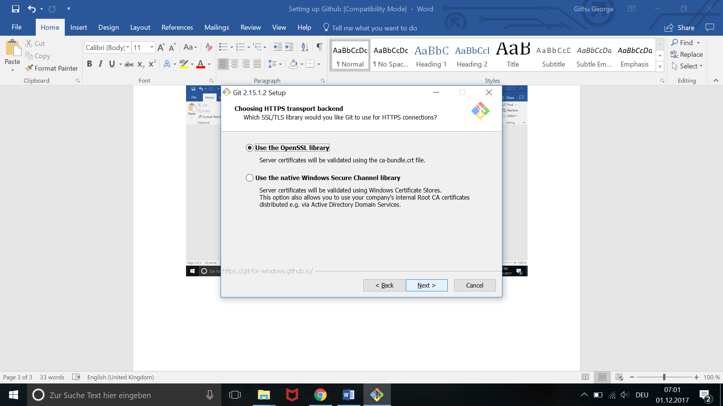

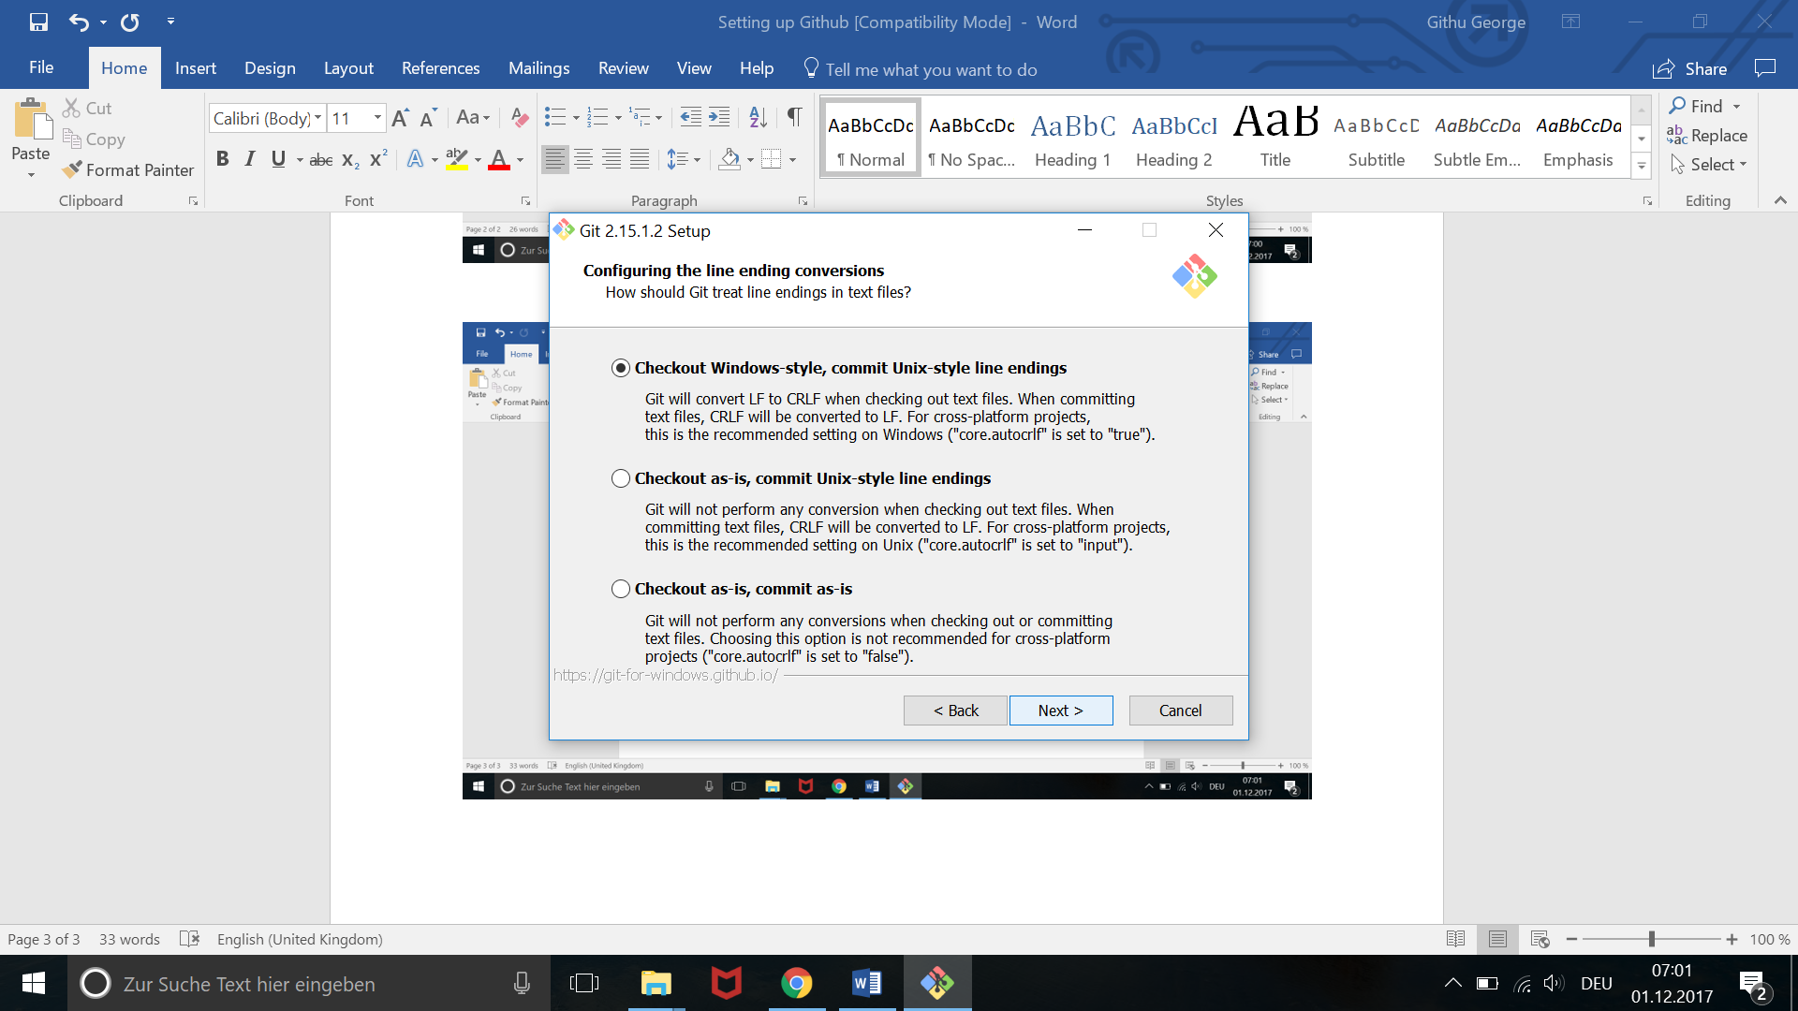

Choose here windows default console window:

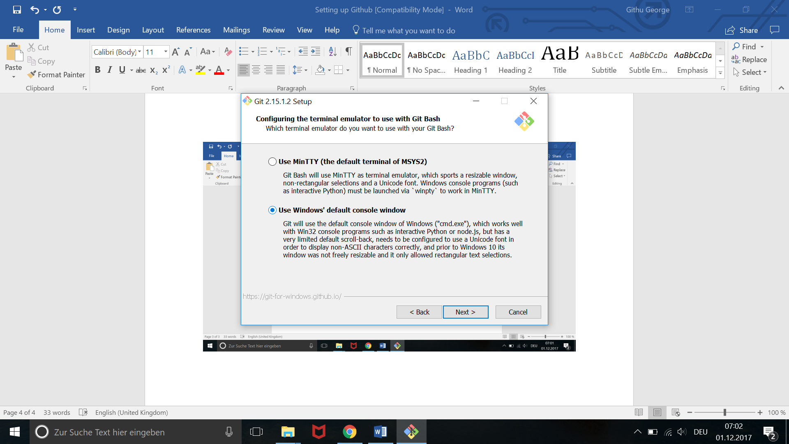

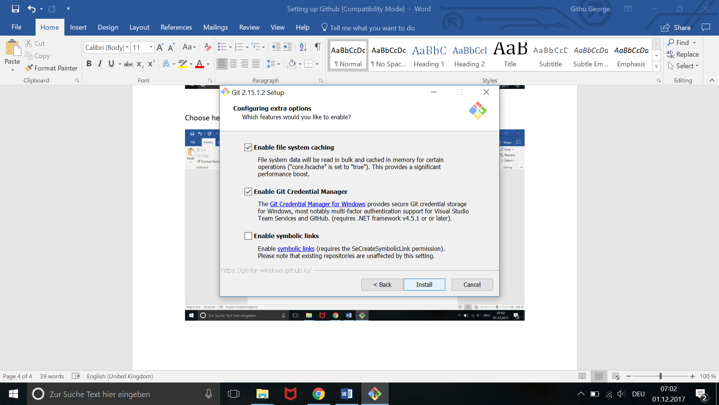

And install:

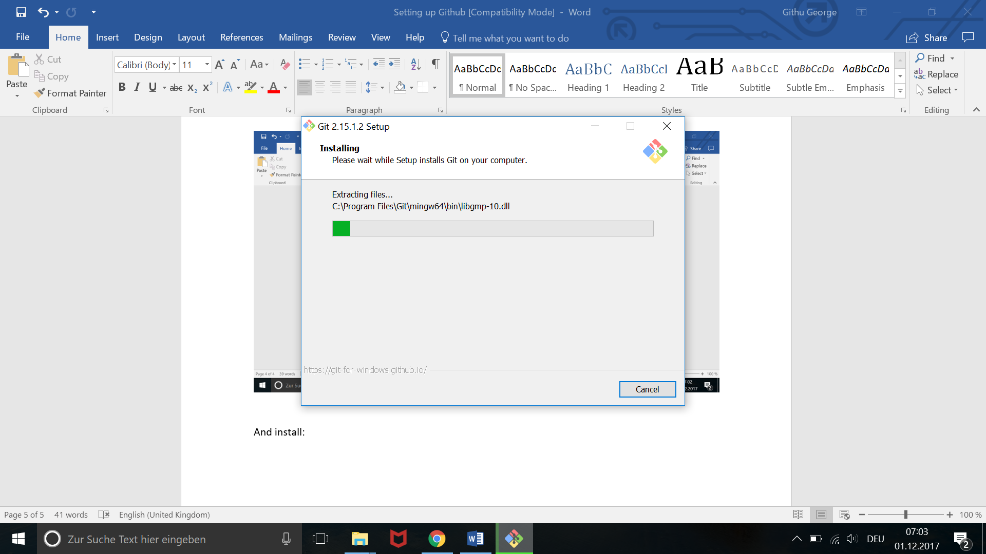

Finish!!

To verify the installation go to command prompt:

And type “ git –version” and enter. It should show the installed git version.

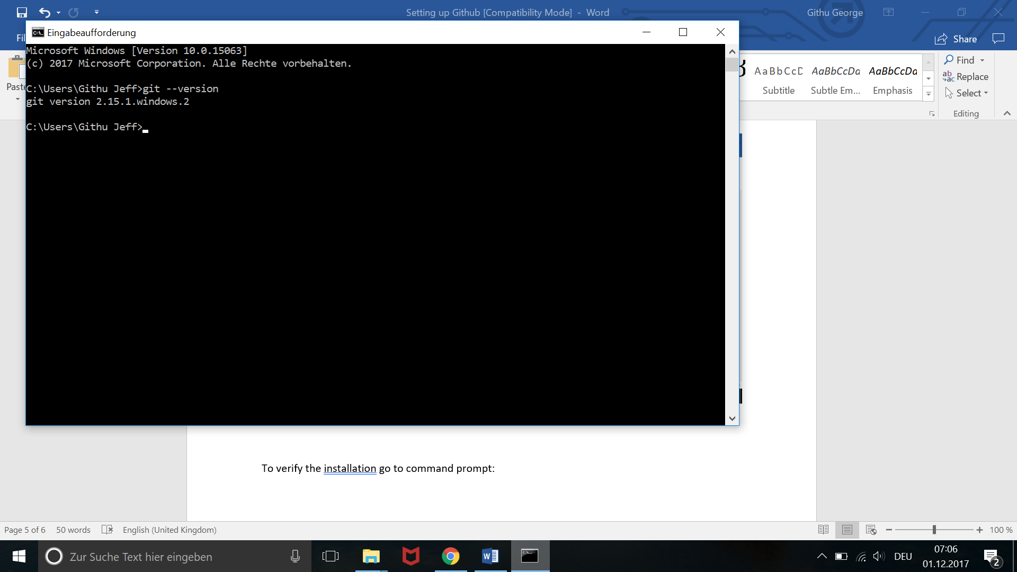

Github Account :

1. Create a github account in github.com

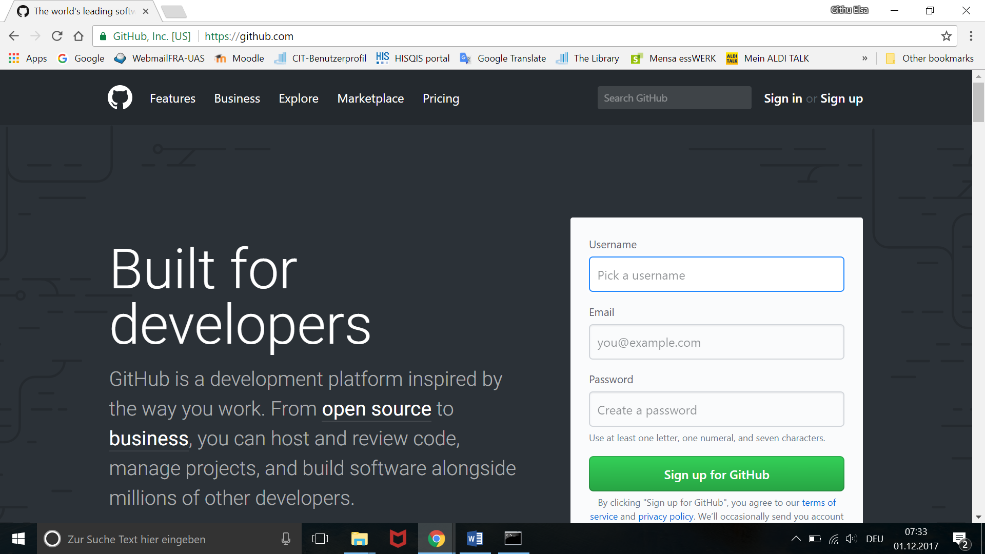

1. Sign In to your account.

Once your account is created, send me your username or mail ids , so that I can invite you to our project account.

1. Once signed in search for the SCSgroupProject/InsulinPump

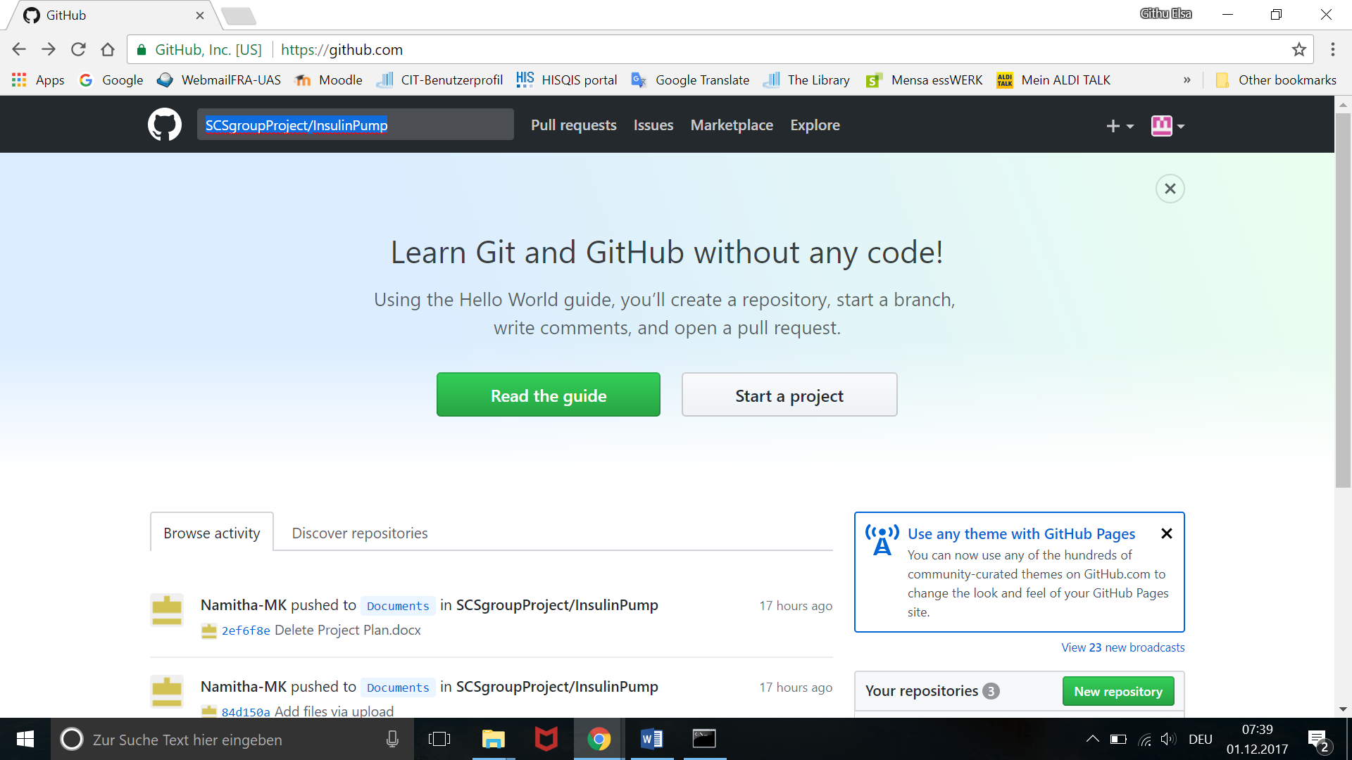

1. Go to that repository.

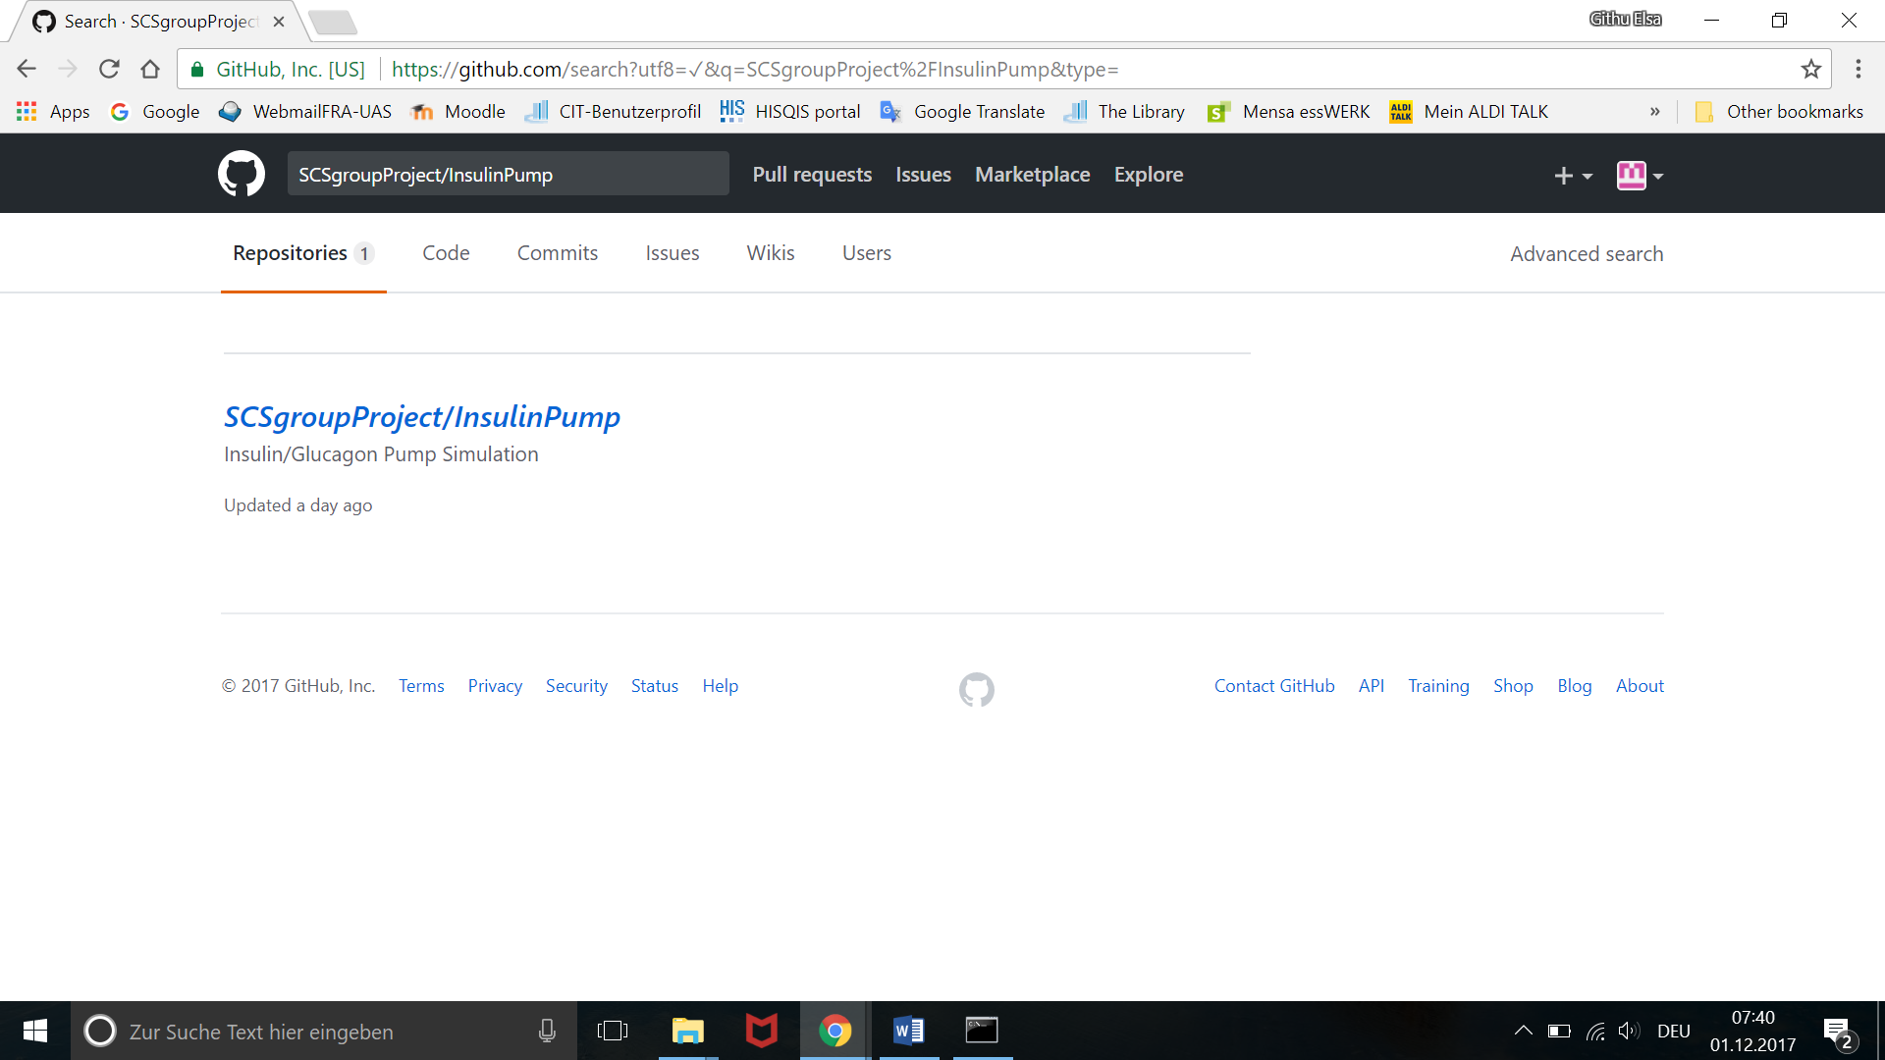

1. Yow will be taken to the project page

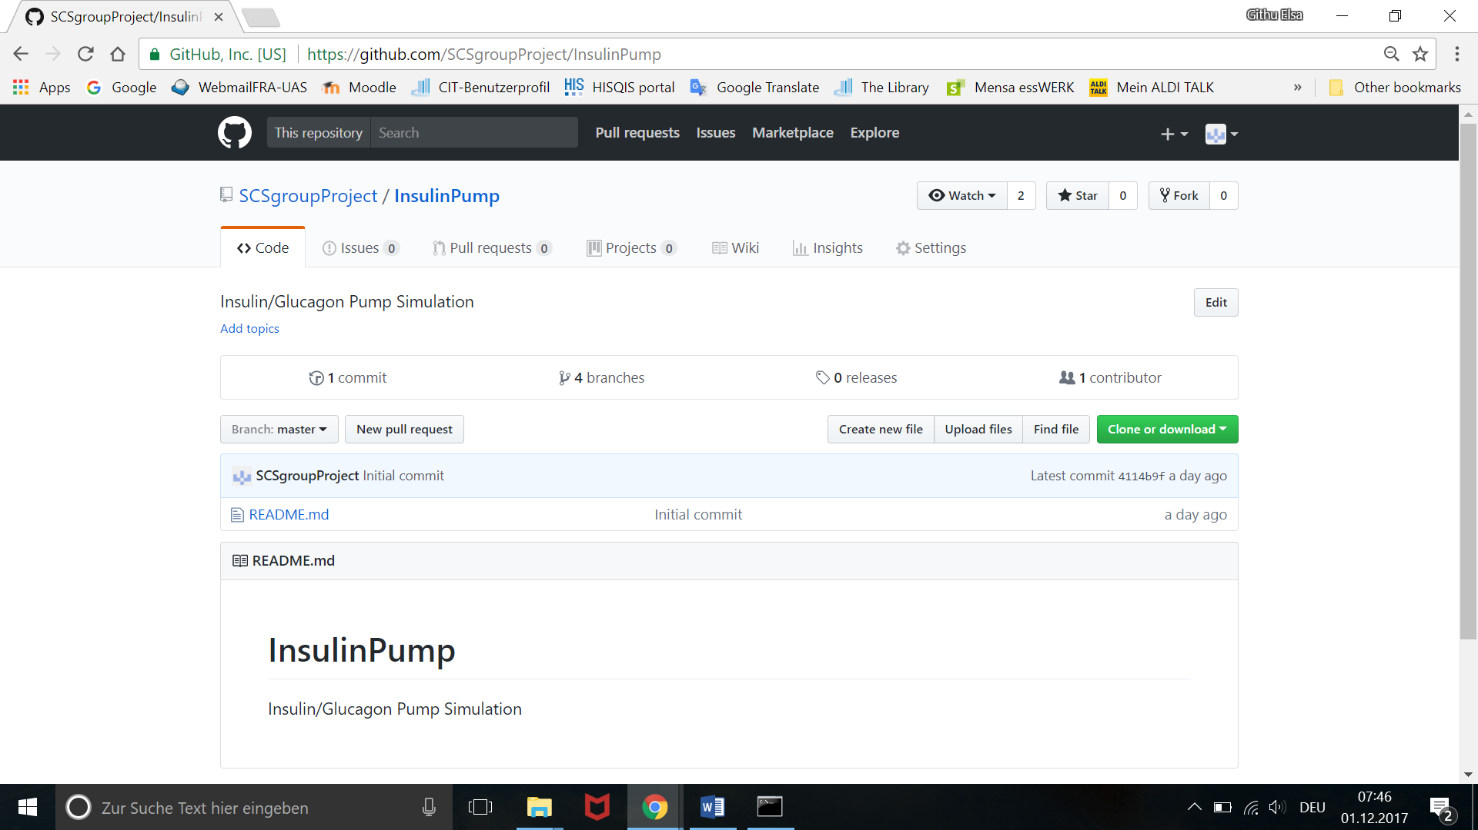

1. Here we have 3 branches under the master

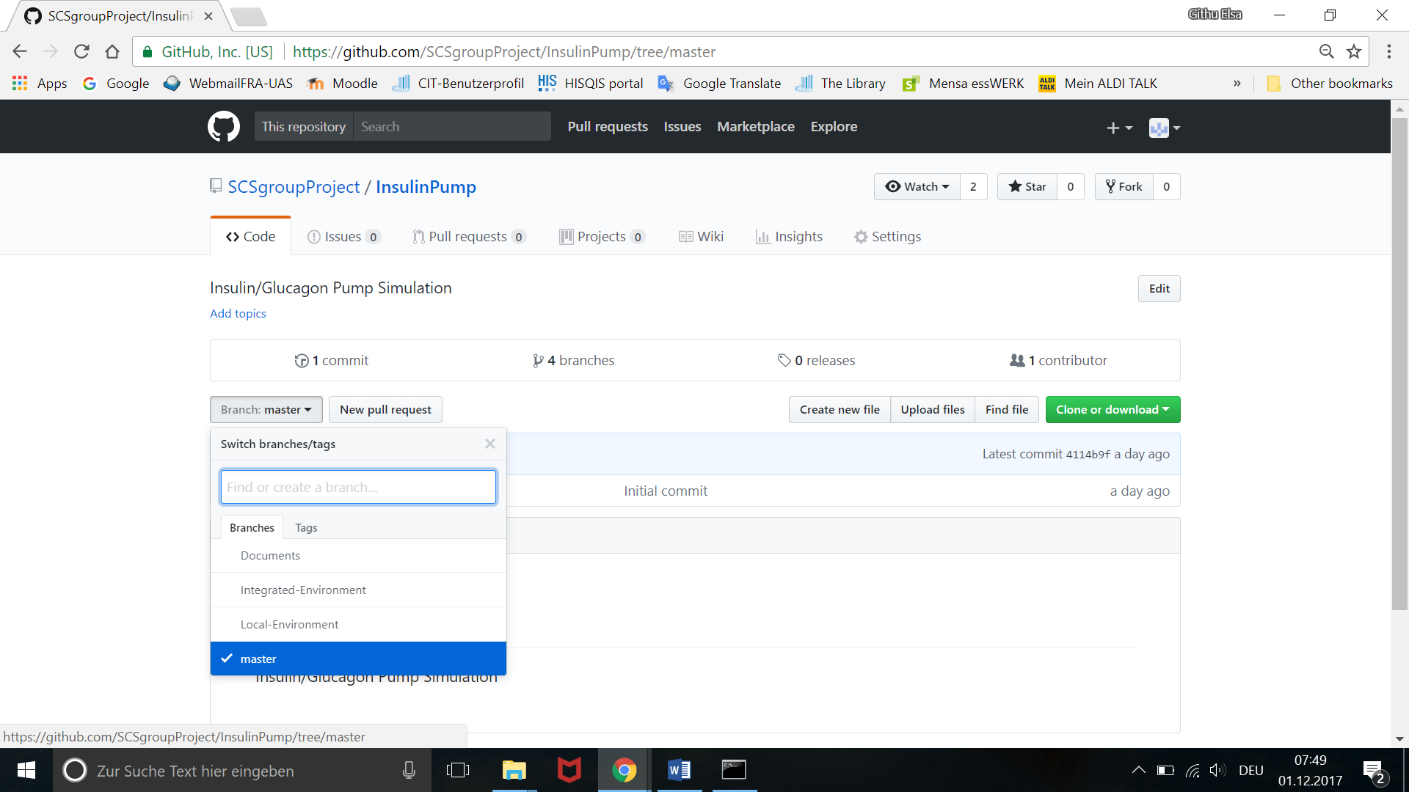

Master – main branch. We won’t touch this branch.

Documents – Where all project related documents will be updated and shared.

Local-Environment – Where we will be uploading and merging our code.

# ATTENTION WHILE YOU MERGE:

Please take care of the below steps when you merge so that you won’t delete a previous commit or other project specific files. Always consult if you have any doubts while commiting.

1. Once you are done with your coding and you are ready to move it to the repository(i.e, you are ready to commit your changes to the Local-Environment), **always**  take the latest repository[using PULL command- Steps will be explained below].
2. Add your Changes to this latest repository.
3. **Inform other Team Members that you are committing, so that they wont commit at the same time. This is important to prevent Commit loss.**
4. Add proper messages to your commits so that we can track it later if needed. The general format expected is “ReasonForCommit_NameDDMMM_0#”. 0#- the number of the commit for you that day.

Eg. PatientViewUpdate_Githu12DEC_01

1. Commit your changes and inform others. Others who are waiting to commit repeat the same steps.

# STEPS TO DOWNLOAD/CLONE THE CODE

* The **clone** command is used to clone the repository to your local machine.
* For this your git installation must be complete and you must use command prompt.
* In command prompt go to your desired folder where you would like to download the code, so that you can always commit or pull latest code to this location.
* Now go to your github profile. Select the insulin pump project.
* Copy the link in the Clone or Download tab:

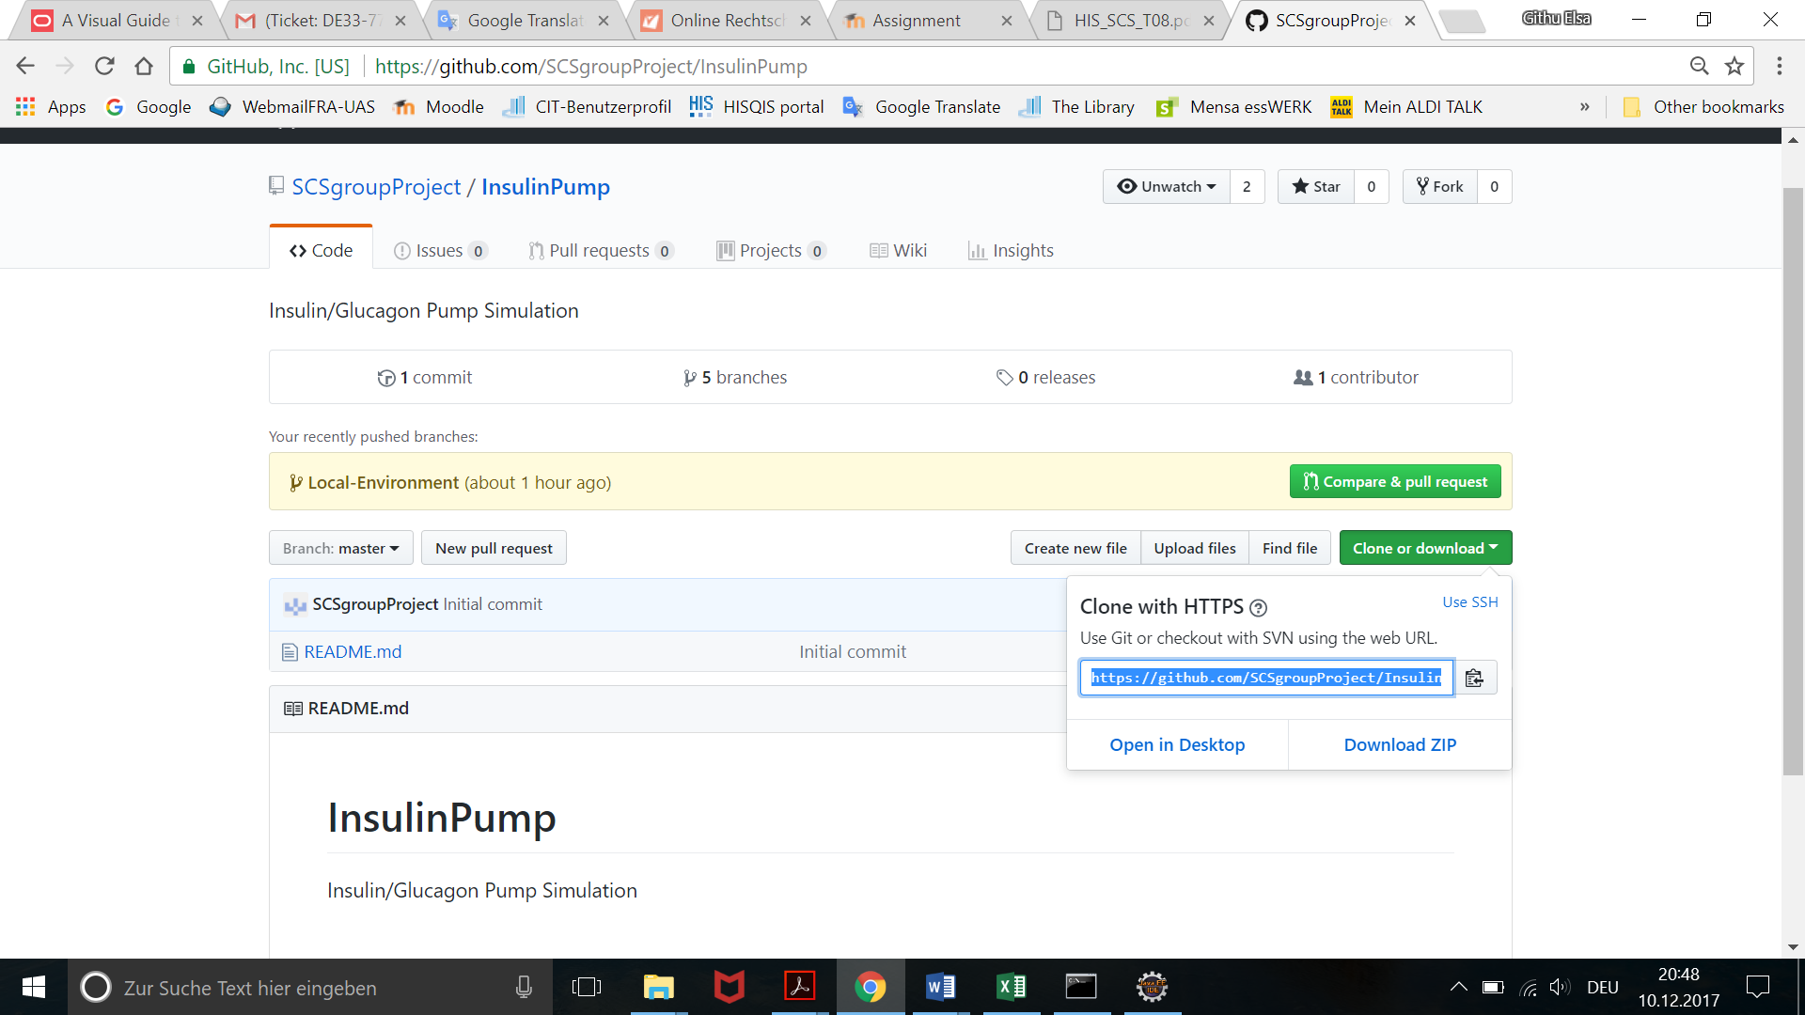

* Now in your command prompt copy and enter the link as below:

git clone https://github.com/SCSgroupProject/InsulinPump.git

So that now the InsulinPump folder will be downloaded to your desired folder.

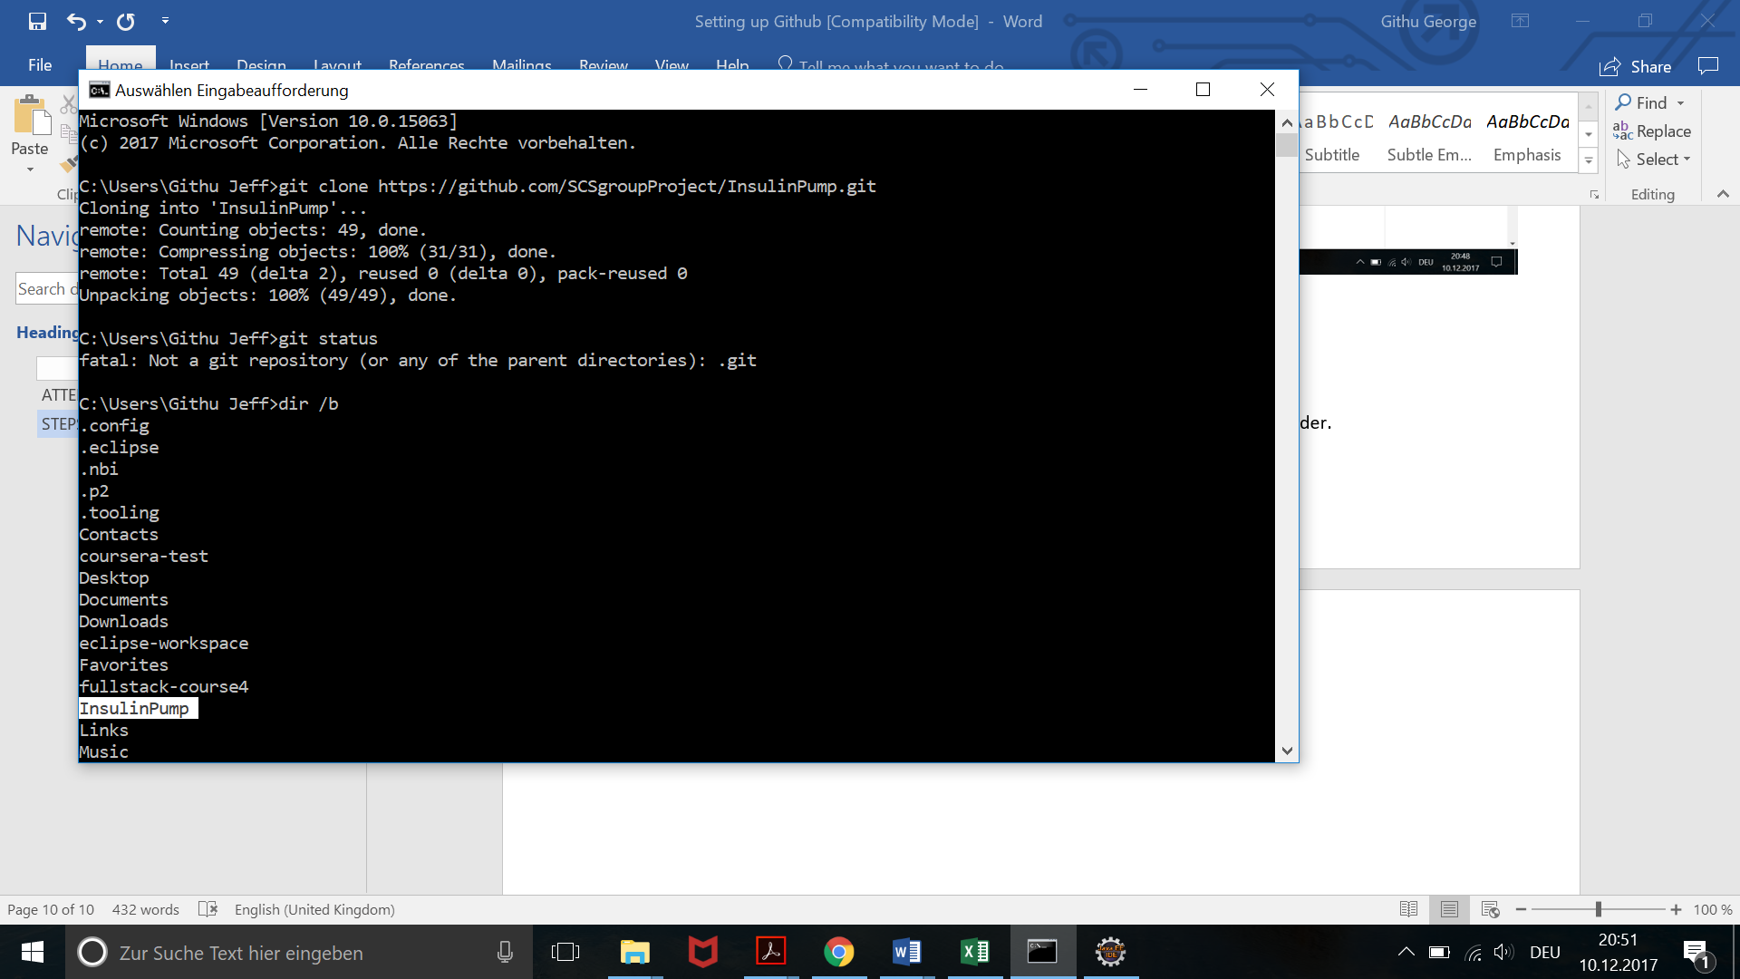

* Now we are in the ‘master’ branch of github[You can check the same using the command ‘git status’]. But we have to be in the **Local-Environment** branch of github, so that our commits will be updated in that folder only. **ATTENTION:** Always ensure this before you commit or download. Execute the below highlighted command to checkout that branch.

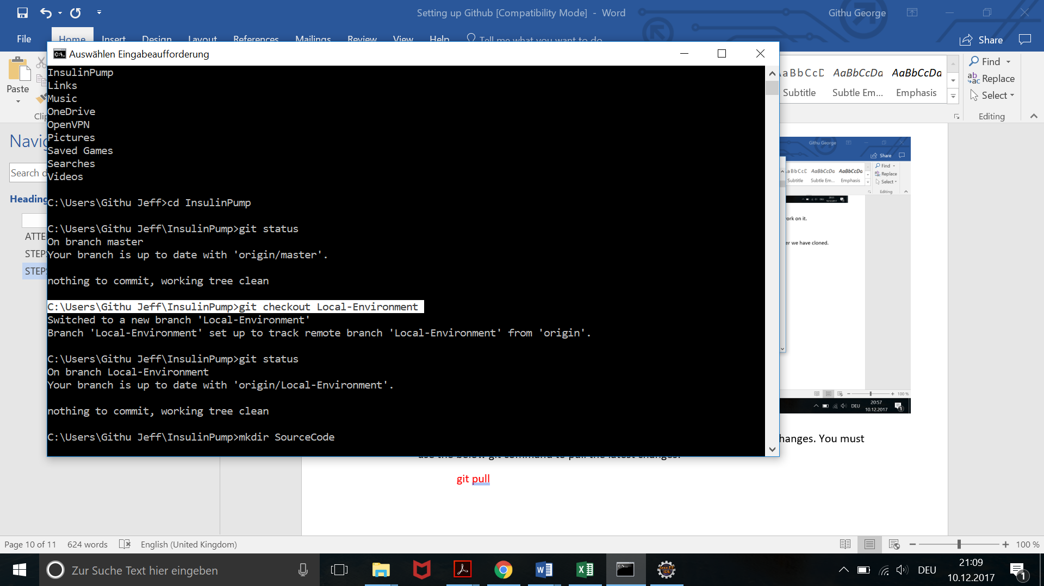

So that the repository is now cloned to your local machine. We are now ready to work on it.

# STEPS TO COMMIT CODE

* In command prompt go the PumpSimulator Folder in the InsulinPump folder we have cloned.

(***Only first line in the below screenshot***)

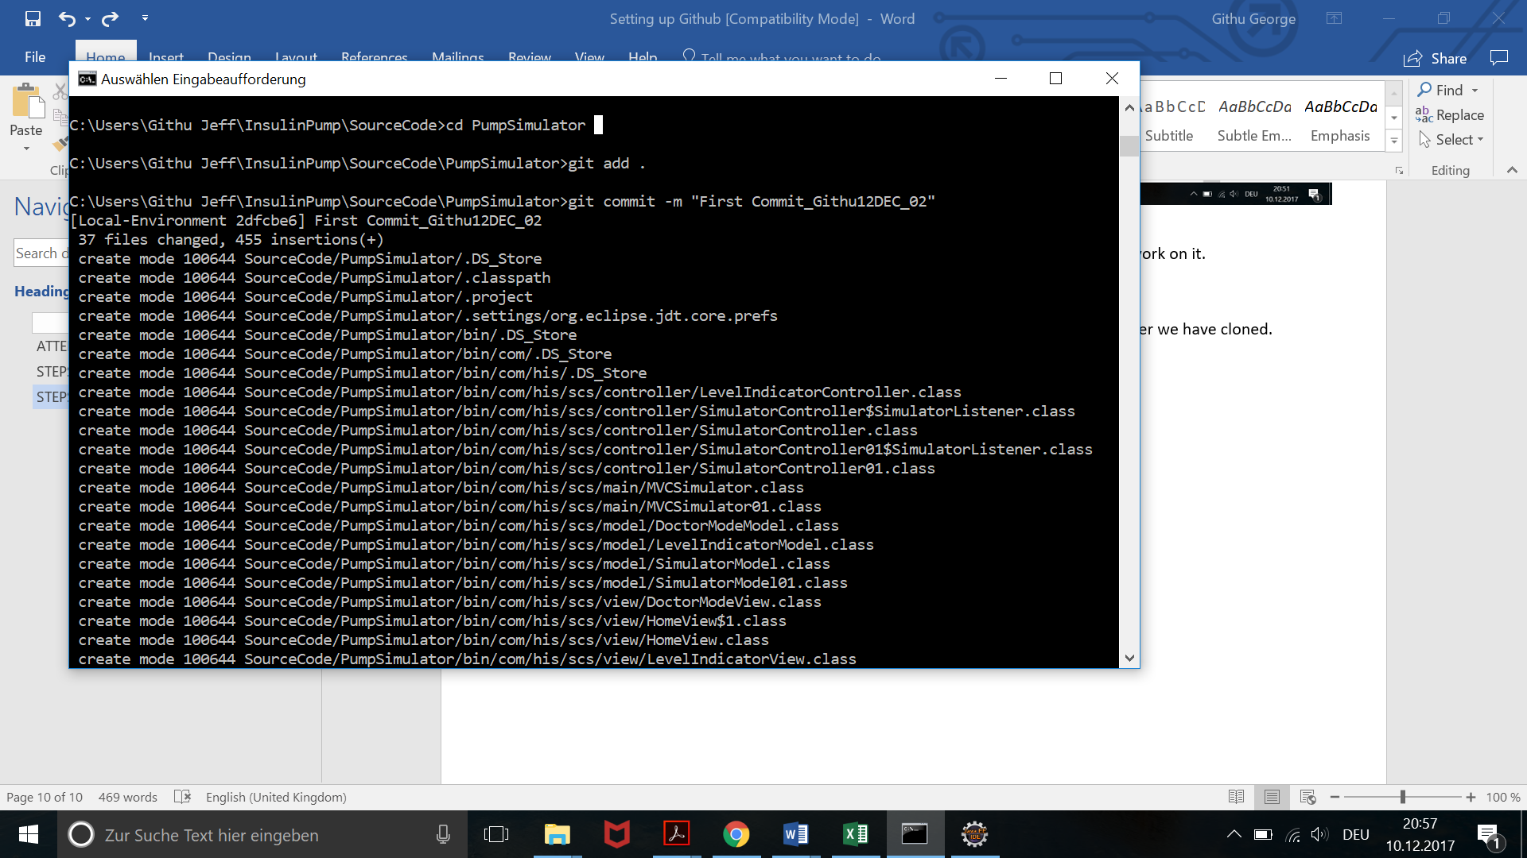

* Once in that folder **pull** the latest changes if anyone has committed their changes. You must use the below git command to pull the latest changes:

git pull

So that the latest changes will be now added to your locally cloned folder.

* Select the file that you are changing. Compare your file with your changes with the file in the cloned folder using BeyondCompare or any other comparing tool. And **carefully** add/paste your changes to the file in the cloned folder. **ATTENTION:** You should not delete or overwrite the changes committed by others.

**NOTE:** If you are uploading a completely new file, you just have to paste the file in the corresponding folder in the cloned location: [InsulinPump\SourceCode\PumpSimulator\src\com\his\scs\ controller or main or view etc]

* Once you have updated the cloned folder with your changes, your cloned folder is now ready to be committed to the project in github.
* In command prompt excute the below steps:
  1. Ensure that you are in PumpSimulator Folder. [eg: C:\Users\Githu Jeff\InsulinPump\SourceCode\PumpSimulator> ]
  2. Check the status : git status

It will show you have new changes in your local folder using the symbol ./

* 1. Execute git add .

[By the above command, we are informing git that we are adding all the new/changed files in our PumpSimulator folder for commit]

* 1. If we check status ‘git status’ again it will show now your branch is ahead of the 'origin/Local-Environment'.
  2. Now execute git commit -m”<Proper message as mentioned in ATTENTION WHILE YOU MERGE>”
  3. Now the code is committed and has to be pushed to github, so that we can see the changes from github. So execute git push.
  4. Refresh github website and check if your changes are reflecting in it.